**Subjective Questions:**

1. **What is the relation between patient wait time and satisfaction scores?**

* A quick measure was created in Power BI by assigning department_referral as the category, patient_sat_score as Measure1, and patient_waittime as Measure2.
* The DAX formula was automatically generated to calculate the correlation between these two measures.
* To visualize the correlation value, a Gauge Chart was used with a range set from 0 to 1.06, where the final correlation value observed was 0.53.

Explanation:

* A correlation value of 0.53 indicates a moderate positive relationship, implying that as wait times increase, satisfaction scores generally decrease, though not in a strictly linear manner.
* This suggests that while wait times impact patient satisfaction, other factors—such as staff behavior, quality of care, or facility conditions—may also play a role.
* The Gauge Chart visually represents this correlation, making it easier to interpret the score and understand its significance within the given range.

Visualization:  
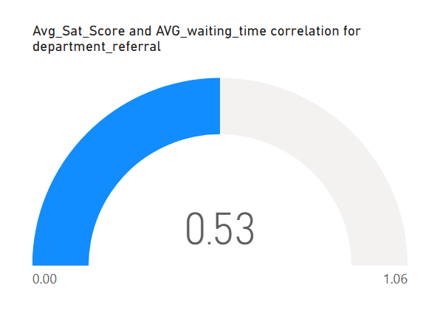

Insight:

* The analysis identified a moderate positive correlation of 0.53, indicating that while patient wait times influence satisfaction scores, the effect is not dominant.
* Departments that minimize wait times or effectively manage patient expectations may achieve higher satisfaction levels, but factors like service quality and communication likely play a significant role in shaping patient perceptions.

DAX Formula  
  
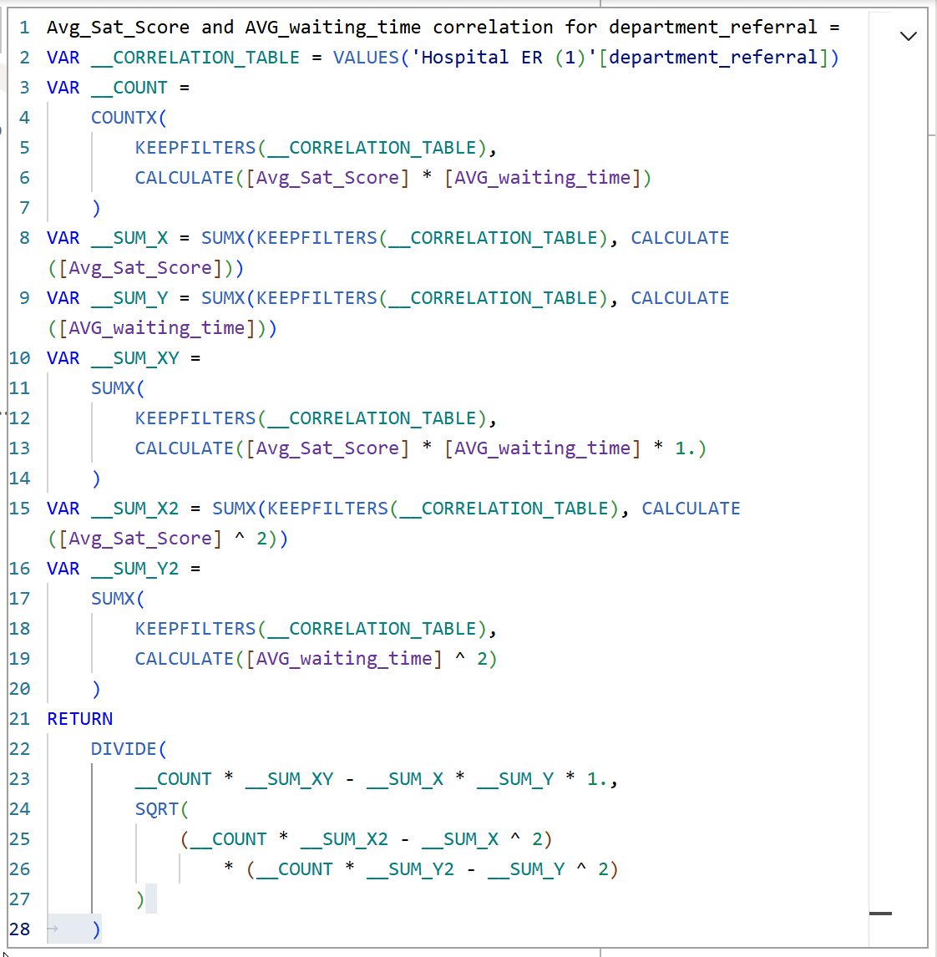

Result:

* This analysis underscores the importance of balancing wait times with other quality-of-service factors to enhance overall patient satisfaction.

1. **How do patient demographics affect the frequency of visits to different departments?**

* Organize the data with columns for Department, Patient Count, and key demographics (Age Group, Race, Gender).
* Construct a Stacked Column Chart, setting Department on the x-axis and Patient Count on the y-axis.
* Implement Field Parameters to enable dynamic filtering, allowing users to switch between demographic variables (Age Group, Race, Gender) for deeper insights.

Explanation

* This analysis aims to understand how patient demographics affect visit frequency across different departments. The Stacked Column Chart provides a visual breakdown of how various demographic groups contribute to the total patient count per department.
* Field Parameters enable dynamic toggling between demographic categories (Age Group, Race, Gender), allowing for a detailed analysis of their impact on department visit frequency.

Visualizations

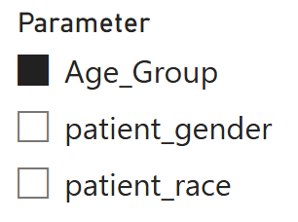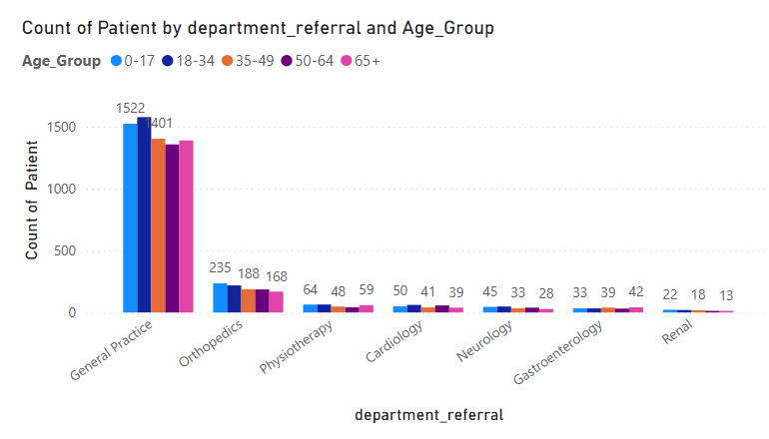

Insight

Demographics do not influence the number of visitors to various departments, as visit frequency primarily depends on the patient's health condition and the hospital's location. The demographic composition of different departments remains largely unaffected.

Result

The Stacked Column Chart confirms that demographic factors have minimal impact on overall visit counts across departments.

1. **Is there a noticeable trend in the volume of patient visits throughout the year?**

* Utilize a Line Chart to illustrate the trend in patient visit volume over time.
* Place Year and Month Name (in a hierarchy) on the x-axis to enable drill-up and drill-down functionality, allowing trend analysis at different time granularities.
* Use the Count_of_Patients measure on the y-axis to track patient visits per month.

Explanation

* This analysis aims to uncover patterns in patient visit volumes throughout the year. A Line Chart with a Year-Month hierarchy helps visualize both annual and monthly fluctuations.
* The Count_of_Patients measure highlights variations in patient visit frequency over time.
* The drill-up and drill-down features allow for both a broad (yearly) and detailed (monthly) view, helping identify seasonal trends or irregular fluctuations in patient visits.

Visualization

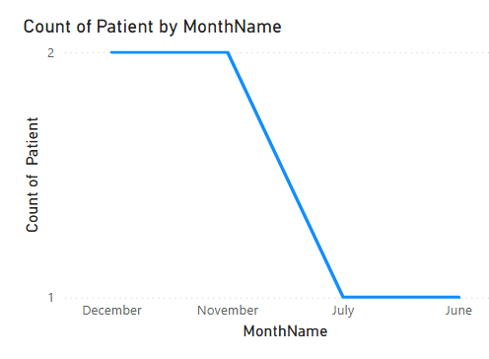

Insight

* In 2019, the total patient visits were 4,338, increasing to 4,878 in 2020, reflecting a 7.5% rise in visits.
* This growth suggests potential shifts in healthcare demand, possibly influenced by factors such as greater healthcare awareness, new medical services, or external events like the pandemic.

Result

* The analysis highlights a notable upward trend in patient visits in 2020 compared to 2019, indicating changing healthcare dynamics.

1. **Which age groups report the highest and lowest satisfaction scores?**Age Group Analysis

* Patient satisfaction scores across different age groups range between 5.05 and 5.15.

Visualization

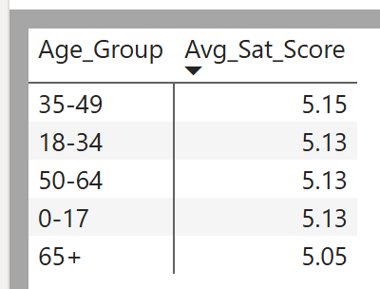

Insight

* Younger and middle-aged patients exhibit slightly higher satisfaction levels compared to older patients.
* This indicates potential areas for service improvements tailored to the needs of senior patients, such as better accessibility, personalized care, or enhanced communication.

1. **Say someone outside of the hospital claims that there is racial or gender-based discrimination in the hospital, how will you identify whether the claim was right or not?**Create a Clustered Column Chart with a Field Parameter on the X-axis, enabling the ability to toggle between race and gender for comparison.

On the Y-axis, plot both average waiting time and average satisfaction score for each group (race and gender).

This chart facilitates the comparison of patient experiences across different race and gender groups, specifically in terms of waiting time and satisfaction scores.

Explanation

* A Clustered Column Chart is used to investigate any potential evidence of racial or gender-based discrimination within the hospital.
* The Field Parameter on the X-axis allows for dynamic switching between race and gender categories, while the Y-axis displays average waiting times and average satisfaction scores.
* By comparing these metrics, we can assess whether certain demographic groups face longer wait times or lower satisfaction, potentially highlighting areas for improvement or discrimination.

Visualization

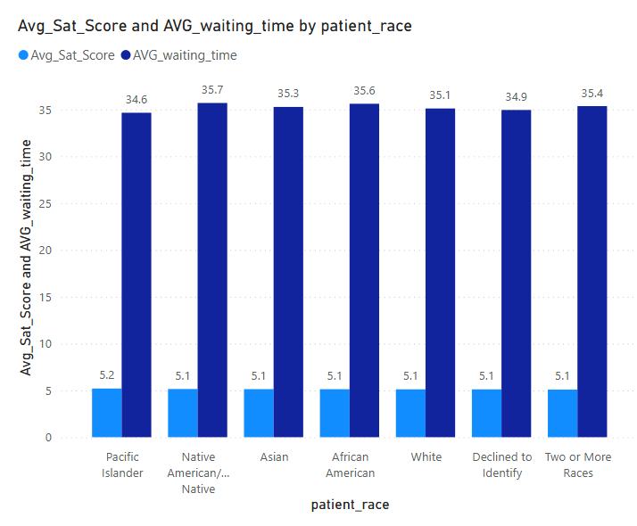

Insight

* Analyzing the average waiting times and patient satisfaction scores indicates no evidence of racial or gender-based discrimination within the hospital.
* The data reflects consistent and equitable treatment across different race and gender groups, with no significant disparities in either waiting times or satisfaction levels.

Result

* The analysis confirms that waiting times and satisfaction scores remain uniform across race and gender groups, suggesting that the hospital maintains fair and non-discriminatory practices.

1. **The hospital management intends to offer discounts to patients. How should these offers/discounts be assigned to patients, on what basis, and why?**

* A DAX formula was applied to determine discount eligibility based on the following conditions:
  + Total Bill ≥ 10,000
  + Satisfaction Score ≥ 6
* A DiscountEligibility column was created to classify patients as either "Eligible" or "Not Eligible."
* A Donut Chart was used to visualize the proportion of eligible vs. non-eligible patients.

Explanation:

* The hospital management aimed to offer discounts to patients who were high spenders and had high satisfaction scores.
* A DAX formula was used to categorize patients based on their total bill and satisfaction score, ensuring that only those meeting both criteria qualified for the discount.

The formula used is:

Discount Eligibility =

IF(

AND('Sheet1'[Total Bill] >= 10000, 'Sheet1'[Sat_Score] >= 6),

"Eligible",

"Not Eligible"

)

Visualisation:

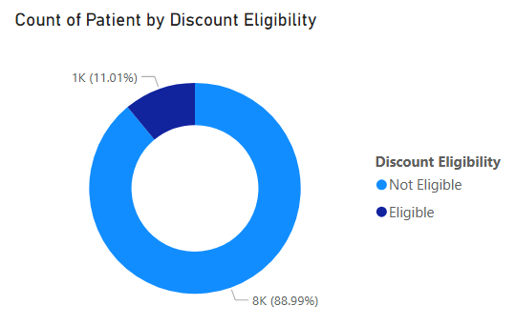

Insight:

* Out of 9,216 total patients, only 11.01% qualified for the discount, while the remaining 88.99% did not.

Result:

The Donut Chart visually highlights that a small proportion (11.01%) of patients meet the discount criteria, whereas the majority (88.89%) do not qualify.

1. **The hospital has a budget to hire 2-3 new doctors. They have asked for your suggestions on which departments they should hire.**

* Analyzed hospital departments using key metrics:
  + Count of Patients
  + Sum of Appointment Fees
  + Sum of Total Bill
* Identified departments needing 2-3 additional doctors based on high patient volumes and revenue.
* Used a table visualization to compare metrics across departments.

Explanation:

* Departments with the highest demand and revenue were prioritized.
* Orthopedics had the highest patient count (995), appointment fees (696,500), and total bill (172,939,773), indicating a need for more doctors.
* General Practice had the largest patient count (7,240) and significant revenue, making it a key department for expansion.
* Neurology had fewer patients (193) but generated high appointment fees and total bills, suggesting a high-value specialty needing additional support.

Visualization:

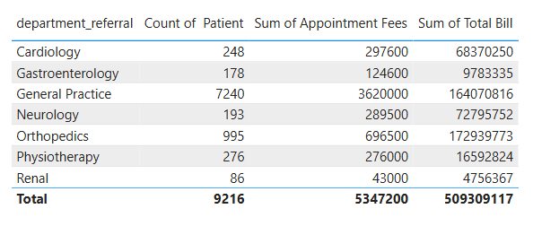

Insight:

* Orthopedics and General Practice have the highest patient load and revenue, making them the top priorities for new hires.
* Neurology, despite having fewer patients, still generates high revenue, indicating strong demand for specialized care.

Result:

Hiring additional doctors in Orthopedics, General Practice, and Neurology is recommended to manage patient demand and maintain service quality.

1. **Is the hospital profitable? How will you determine the profitability?**

Created a visual table displaying Year and Month as columns and used DAX measures to calculate key profitability metrics  
  
 Total Revenue = SUM('Sheet1'[Total Bill])  
  
Total Appointment Fees = SUM('Sheet1'[Appointment Fees])

Total Profit = [Total Revenue] - [Total Appointment Fees]

Profit Percentage = DIVIDE([Total Profit], [Total Revenue], 0) * 100

Explanation:

* The profit margin remained consistently high, around 98.95% and 97.59%, indicating strong financial performance.

Visualization: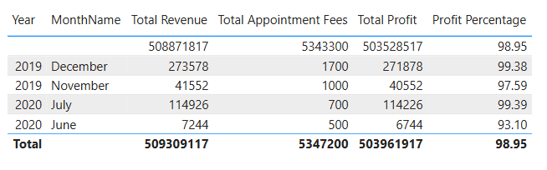

Insight:

* The hospital maintains a high profit margin exceeding 90%, confirming its strong profitability.
* Revenue generation is substantial, while costs (appointment fees) remain low, contributing to the high margins.

Result:

With a consistent profit percentage above 98%, the analysis confirms that the hospital is highly profitable and operates with a very high margin.

1. **Any Department for which the waiting time is oddly large?**

* Created a Line Chart with Department on the x-axis and Average Waiting Time on the y-axis to visualize waiting time variations across departments.
* This allowed for a clear comparison and identification of departments with unusually long waiting times.

Explanation:

* The line chart revealed differences in waiting times between departments.
* Neurology had the highest average waiting time at 36.80 minutes, standing out significantly from other departments.

Visualization:

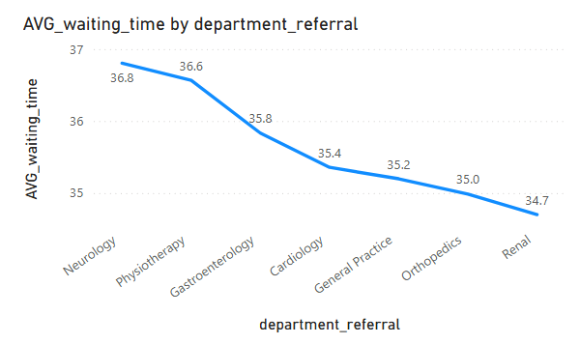

Insight:

* The high waiting time in the Neurology department may point to potential staff shortages, high patient demand, or scheduling inefficiencies that need addressing.

Result:

Neurology was identified as having the longest average waiting time at 36.80 minutes,  
 which is notably higher than other departments, highlighting an area for improvement.

1. **Come up with strategies to provide discounts to the patients.**

Reward High Spenders:

Provide discounts to patients with a total bill exceeding ₹10,000 to recognize and reward high spenders.

Encourage Loyalty:

Offer discounts to patients with a satisfaction score of 6 or above to foster loyalty and incentivize positive feedback.

Tiered Discounts:

Introduce tiered discount levels based on the total bill amount:

* + 5% for bills between ₹10,000–₹20,000
  + 10% for bills above ₹20,000

Compensate for Long Wait Times:

Provide compensatory discounts to patients with unusually long waiting times, helping improve their overall experience and satisfaction.

Seasonal or Promotional Discounts:

Offer seasonal or promotional discounts during low-demand periods to attract more patients and balance patient flow.

1. **Say you need to align the doctors of the “General Practice” department to work in one of the two shifts, how will you identify what will these two shifts' timings be, and how will you divide the doctors in these two shifts? And also will this 2 shift policy be helpful for the hospital?**

* Created a table visualization with Doctor Name and Department to display the list of doctors and their respective departments.
* Used DAX to assign doctors to two shifts:
  + 8:00 AM - 2:00 PM
  + 2:00 PM - 8:00 PM
* Applied conditional formatting to highlight the General Practice department for better visibility.

Explanation:

The DAX formula used to assign doctors to shifts is as follows:

Shift =

IF(

MOD(RANKX(ALL('Sheet1'),'Sheet1'[Doctor Name], ,ASC),2) = 0,

"8:00 AM - 2:00 PM",

"2:00 PM - 8:00 PM"

)

The formula used also ranks doctors by name and alternates shift assignments using the MOD function. This ensures a balanced distribution of doctors across shifts, based on patient volume.

In this case:

* Dr. Johnson and Dr. Williams were assigned to the morning shift (8:00 AM - 2:00 PM) due to higher patient traffic.
* Dr. Smith was assigned to the evening shift (2:00 PM - 8:00 PM) to manage lower patient volume during those hours.

Visualisation:

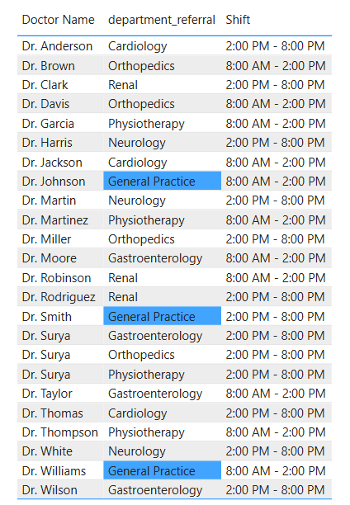

Result:

The two-shift policy helps achieve an even distribution of workload among doctors, ensuring that patient care is more efficient and that wait times are reduced.

This approach is particularly beneficial in the General Practice department, where the patient flow is typically higher, allowing for better management of patient demand and enhancing overall service quality.

1. **What do you understand by PowerBI gateway? What are its use cases?**

Power BI Gateway:

A Power BI Gateway is a tool that enables the secure transfer of data between on-premises data sources (such as databases or Excel files) and the Power BI cloud service, allowing you to refresh and access data stored locally within your reports and dashboards.

Use Cases:

* Data Refresh:  
  Automatically refreshes on-premises data to ensure reports and dashboards are always up to date.
* Secure Data Transfer:  
  Ensures that data is encrypted and securely transferred between on-premises sources and Power BI, maintaining confidentiality and compliance.
* Access On-Premises Data:  
  Allows you to incorporate on-premises data (e.g., SQL Server, Excel files) into Power BI for comprehensive reporting.
* Hybrid Data Integration:  
  Combines on-premises and cloud data into unified, seamless reports for better analysis and decision-making.
* DirectQuery:  
  Enables real-time querying of live data sources in Power BI, ensuring that the most recent data is always used in reports and visualizations.

Types of Gateways:

* Personal Gateway:  
  Designed for individual use, allowing personal data refreshes without the need for multiple users or large-scale deployments.
* Enterprise Gateway:  
  Aimed at organizations with multiple users and data sources, supporting large-scale data refresh and integration for team-based reporting.

1. **How would you approach this problem, if the objective and subjective questions weren't given?**

Steps for Data Analysis in Power BI:

* Import the Data:  
  Begin by importing the dataset into Power BI to initiate the analysis process.
* Use Power Query for Data Transformation:  
  Utilize Power Query to filter, merge, and shape the data to match the required structure, ensuring it’s ready for analysis.
* Clean the Data:  
  Address any inconsistencies, handle missing values, correct data types, and standardize formats across the dataset to ensure accuracy and consistency in the analysis.
* Identify Key Performance Indicators (KPIs):  
  Identify the most relevant KPIs based on the objectives of the analysis, focusing on metrics that will provide meaningful insights for decision-making.
* Analyze Each KPI:  
  Dive deep into each KPI by exploring trends, relationships, and patterns to uncover insights that align with the analysis goals.
* Create Reports and Dashboards:  
  Develop comprehensive reports and dashboards using various visualizations like bar charts, line graphs, and tables to effectively communicate findings.
* Add Interactive Slicers and Filters:  
  Enhance the reports by adding interactive slicers and filters, allowing users to dynamically explore the data based on different dimensions for more personalized analysis.
* Review and Finalize the Report:  
  Review the final report for accuracy, clarity, and relevance. Provide actionable recommendations based on the insights gathered during the analysis process to support informed decision-making.

1. **Can you analyze and write the type of relationship between the doctor id and department, is it one-to-one?**

* Unique Doctor Assignment:  
  Each doctor is assigned to one department, ensuring clarity in the structure of the organization.
* Multiple Doctors per Department:  
  A single department can have multiple doctors, which allows for specialization within that department.
* Data Modeling:  
  In a relational database, you can set up a foreign key on the doctor table that references the department table, linking each doctor to their respective department.
* One-to-Many Relationship:  
  When analyzing the relationship, think of the department as the “one” side and the doctors as the “many” side. Each department can have many doctors, but each doctor is limited to only one department.
* Querying and Reporting:  
  In reports or queries, you can aggregate data by department (e.g., count of doctors per department) or drill down to see the details for each individual doctor.
* Data Integrity:  
  Enforcing this relationship helps maintain data integrity, ensuring that each doctor is assigned to only one department, preventing errors in reporting or data analysis.
* Department-Level Metrics:  
  Departments can be analyzed independently (e.g., department-wise doctor count) or combined with other metrics like patient load, performance, or financials.